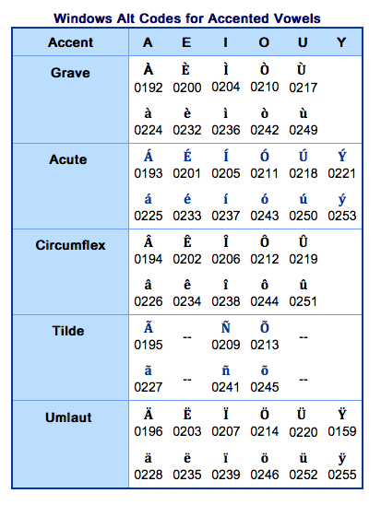
Windows ALT Accent Codes

Example: To input the acute a á (0225), hold down the ALT key,
type 0225 on the numeric keypad, then release the ALT key.

