Snow Day # 8

**Kindergarten Snow Day Assignment Checklist for Snow Day Number 8**

Please Print the following pages. Complete and return the checklist and all completed pages to school within 2 weeks.

Name:______________________________________

_______ Complete the subtraction paper

_______ Count to 100 by one’s

_______ Count to 100 by ten’s

_______ Use the alphabet paper to name the letters

_______ Use the alphabet paper to say the sound for each letter

_______ Complete the consonant, vowel, consonant (CVC) paper

_______ Practice writing name on writing paper (Write your child’s first and last name in the

pencil and have them write their name on the lines below.)

_______ Complete syllable paper

_______ Read a story to your child you have at home and talk about the story

Title of story:_____________________________________

Parent Signature:________________________________ Date:___________

Signature indicates that all activities have been completed.

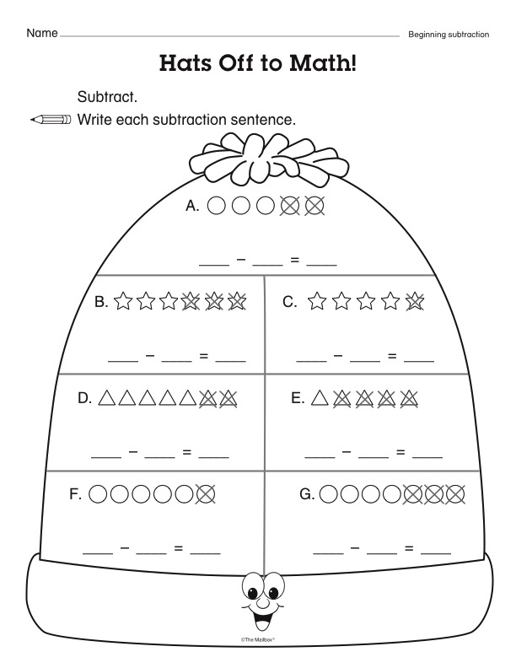



Parent Signature:_______________________________________ Date:____________



